**Student Information**

* **Name:- Aditya Kumar**
* **Sap Id :- 590015145**
* **Branch :- M.C.A**
* **Batch :- B1**
* **Instructor :-Dr. Sourbh Kumar**

**Lab Assignment 1: Understanding Union vs Structure**

**#include <stdio.h>**

**#include <string.h>**

***union* Employee {**

***char* name[50];**

***int* id;**

***float* salary;**

**};**

***struct* EmployeeInfo {**

***char* name[50];**

***int* id;**

***float* salary;**

**};**

***int* main() {**

***union* Employee emp1;**

***struct* EmployeeInfo emp2;**

**// Assign values to union members**

**strcpy(emp1.name, "Alice");**

**emp1.id = 1234;**

**emp1.salary = 50000.0;**

**// Assign values to struct members**

**strcpy(emp2.name, "Bob");**

**emp2.id = 5678;**

**emp2.salary = 60000.0;**

**printf("Union Employee Details:\n");**

**printf("Name: %s\n", emp1.name);**

**printf("ID: %d\n", emp1.id);**

**printf("Salary: %.2f\n", emp1.salary);**

**printf("\nStruct Employee Details:\n");**

**printf("Name: %s\n", emp2.name);**

**printf("ID: %d\n", emp2.id);**

**printf("Salary: %.2f\n", emp2.salary);**

**printf("\nSize of union: %zu bytes\n", sizeof(emp1));**

**printf("Size of struct: %zu bytes\n", sizeof(emp2));**

**return 0;**

**}**

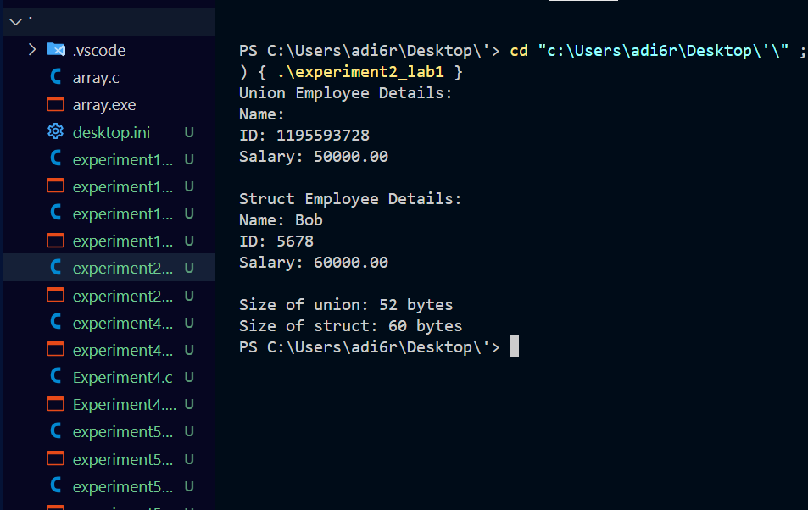

**Lab Assignment 2: Dynamic Memory Allocation with malloc() and free()**

**#include <stdio.h>**

**#include <stdlib.h>**

***int* main()**

**{**

***int* n;**

**printf("Enter the number of elements: ");**

**scanf("%d", &n);**

**// Dynamically allocate memory for an array of n integers**

***int* *arr = (*int*\*)malloc(n * sizeof(*int*));**

**if (arr == NULL)**

**{**

**printf("Memory allocation failed!\n");**

**return 1;**

**}**

**printf("Enter %d elements:\n", n);**

**for (*int* i = 0; i < n; i++) {**

**scanf("%d", &arr[i]);**

**}**

***int* sum = 0;**

**for (*int* i = 0; i < n; i++)**

**{**

**sum += arr[i];**

**}**

***float* average = (*float*)sum / n;**

**printf("Sum of elements: %d\n", sum);**

**printf("Average of elements: %.2f\n", average);**

**// Free the allocated memory**

**free(arr);**

**return 0;**

**}**

